**(System Call for removing Media Devices)**

In Linux operating system, Whenever a removable media or a storage device is attached to a computer, a block driver is initialized and all information about that media is stored in a Data structure called **Gendisk**.

**-My approach-**

* Gendisk data structure includes many variables like **major**, **minor**, **device name** and each of these stores information about a device.
* When a device is attached, its structure is initialized and structure pointer is passed to a function known as **add_disk**.
* I need to tackle those pointers, which does not include hard disk and DVD rom. For this, I reviewed the naming convention to devices, which is below.

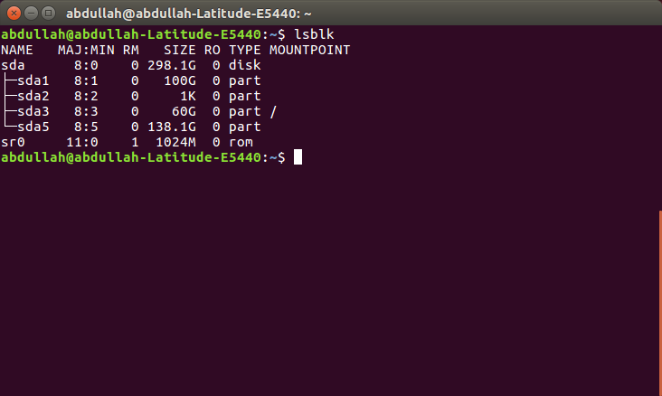

Here you can see, **sr0** is rom and **sda** is harddrive. So, I neglected them and copied all other pointers in my own **initialized** Gendisk data_structure array.

* Now, if u have pointers so you easily remove the associate devices by using a function known as **del_gendisk.**

**-My Functions-**

* I created two functions, one for display number of removable devices attached and other to remove it.
* Display function displays devices with their order number, which had to be passed to remove function in order to remove it.

**-Working-**

I listed all devices using Linux terminal command **lsblk.** Below is a list of devices which includes my **2 usb’s** with names **sdb and sbc.**

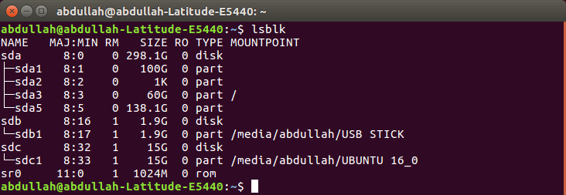

Now, I will run my system call to detect those devices.

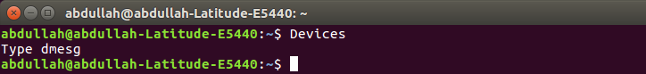

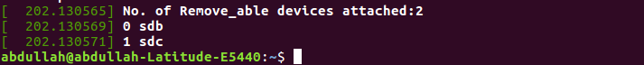

Now, I will run second system call to remove them

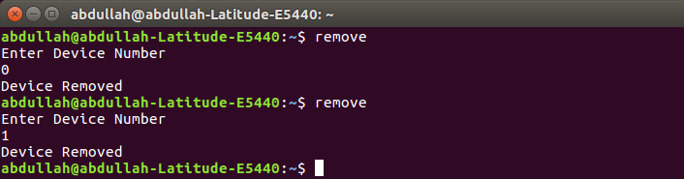

Now, they are successfully removed and are not visible below.

